**CURRICULUM VITAE** 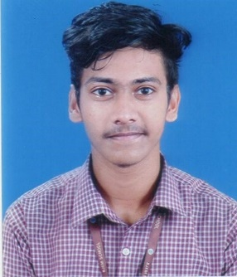

**NAME**: JYOTI PRAKASH ROUT

**EMAIL**: [jyotiprakashrout2002@gmail.com](mailto:jyotiprakashrout2002@gmail.com)

**MOBILE:** 7978110490

**Address for Correspondence**:

|  |  |  |
| --- | --- | --- |
| At: 3450, Badagada Uparsahi | Dist.: Khordha | Odisha |
| PO: Brit Colony,Bhubaneswar | India | Pin: 751018 |

**Career Objective**:

* To pursue a successful career in a professionally managed organization.
* My strength is my Adaptability, hard work , Consistency, Dedication for the work.

**Academic Profile**:

B.Tech(Computer Science & Engineering)| ITER,SOA University| BBSR | 7.6 CGPA(till 5th semester)

12th CBSE-PCM | Buxi Jagabandhu English Medium School | Bhubaneswar| 80.6 % aggregate

10th CBSE | Buxi Jagabandhu English Medium School | Bhubaneswar | 84% aggregate

**Academic Achievements/Awards and Honors**

* Best debutant coder in Hackathon 5.0 by UPES

**Thesis/Projects**

* Made one application on women empowerment.

-This app can help working/independent women to directly contact the wholesalers for

purchasing of raw materials and then selling clothes(tailoring),Groceries etc through this

application.

* Made a to To-Do List website.
* Made a E-commerce website.

**Subjects Of Interest:**

* Web Development
* DBMS
* Artificial Intelligence

**Workshop/Conference Attended**:

* Attended AI4 Students workshop to gain basic knowledge about Artificial Intelligence & Machine Learning.
* Attended workshop on Career, Growth and Android Development organized by UPES-CSI.

**Software Exposed**:

* Java, C++, HTML, CSS, Jquery

**Personal Skills:**

* Analytical, Time Management, Project Management, Creative Thinking, Adaptability.

**Hobbies:**

* Making Event reels in Instagram.
* Playing cricket, Multiplayer FPS videogames.

**Languages Known:**

* English, Hindi, Odia.

**Declaration:**

I do hereby declare that all the information’s are true to the best of my knowledge and belief.

**Date**: 28-06-2022 Jyoti Prakash Rout

**Place**: Bhubaneswar Signature